**Software Requirements Specification**

**For**

**Carselecta.com**

Version 1.0

**Prepare by Project Team 20**

|  |  |
| --- | --- |
| **Name** | **PRN** |
| Kunal B Suryawanshi | 230340520043 |
| Minal D Patil | 230340520051 |
| Anand B Wavne | 230340320011 |
| Anuj Yadav | 230340520017 |
| Praveenkumar Chavhan | 230340520068 |
| Jayesh Nikumbh | 230340520040 |

**Centre for Development of Advanced Computing Raintree Marg,** Near Bharati Vidyapeeth, Opp. Kharghar Railway Station, Sector 7, CBD Belapur, Navi Mumbai - 400 614 - Maharashtra (India) Phone: +91-22-27565303 Fax: +91-22-2756-0004

Contents

Revision History 3

1. Introduction 4

1.1 Purpose 4

1.2 Intended Audience and Reading Suggestions 4

1.3 Project Scope 4

1.4 References 5

2. Overall Description 6

2.1 Product Perspective 6

2.2 Product Features 6

2.3 User Classes and Characteristics 6

1. Customers: 6

2. Admins: 7

Operating Environment 7

2.4 Design and Implementation Constraints 7

2.5 User Documentation 8

Assumptions: 8

Dependencies: 8

4. External Interface Requirements 9

4.1. User Interfaces: 9

1. Login and Account Creation 9

2. Dashboard and Navigation 9

3. Managing User Account 9

4.2 Hardware Interfaces: 9

1. Introduction 9

2. Device Requirements 9

3. Internet Connection 9

4. Input Devices 10

4.3 Software Interfaces: 10

4.4 Communication Interfaces: 10

5. Other Nonfunctional Requirements 11

5.1. Performance Requirements 11

5.2. Safety Requirements 11

5.3. Security Requirements 11

5.4. Software Quality Attributes 11

# Revision History

|  |  |  |  |
| --- | --- | --- | --- |
| **Name** | **Date** | **Reason For Changes** | **Version** |
|  |  |  |  |
|  |  |  |  |
|  |  |  |  |
|  |  |  |  |
|  |  |  |  |

# Introduction

## 1.1 Purpose

The purpose of this document is to provide a comprehensive description of the CarSelecta website. This document outlines the functional and non-functional requirements for the website, provides detailed description of the website's functionalities, such as the car search, car comparison, and car buying process. The SRS document also outlines the performance and security requirements for the website.

## 1.2 Intended Audience and Reading **Suggestions**

The document is intended for a broad audience, including developers, car buyers, and car sellers.

For developers, the SRS document serves as a comprehensive guide for the design and development of the website. It outlines the functional and non-functional requirements, performance expectations, and security considerations, providing a clear understanding of the scope of the project. Developers should read the document carefully to ensure that their work aligns with the specified requirements and meets the expectations of all stakeholders.

For car buyers, the SRS document provides an overview of the website's capabilities and the car search, car comparison, and car buying process, helping them to understand how to use the website effectively. They should read the document to gain a general understanding of the website's functionalities and how they can benefit from it.

For car sellers, the SRS document outlines the goals and objectives of the project and provides a clear understanding of the website's capabilities, helping them to determine whether the website is suitable for their needs. The document should be read by relevant decision-makers to ensure that the website meets their requirements and expectations.

## 1.3 Project Scope

The scope of the CarSelecta website project defines the boundaries of the project, outlining what the system will and will not do. The scope of the project includes the following:

Development of a website for car buyers to search, compare, and buy cars.

Implementation of a user authentication and authorization system to ensure secure access to the website.

Implementation of a car search engine that allows users to search for cars by make, model, year, price, and other criteria.

Implementation of a car comparison tool that allows users to compare cars side-by-side on a variety of factors, such as price, features, fuel efficiency, and safety ratings.

Implementation of a car buying process that allows users to purchase cars online or in person.

Additional features: car reviews, car news, and a blog about the automotive industry.

Development of a secure website to protect the privacy and security of users' personal information.

## 1.4 References

• https://spring.io/

• https://www.javascript.com/

• https://developer.mozilla.org/en-US/docs/Web/JavaScript

• https://en.wikipedia.org/wiki/Model%E2%80%93view%E2%80%93controller

# Overall Description

## 2.1 Product Perspective

The CarSelecta Application is designed to tackle the challenges posed by traditional car purchasing methods. With the rising interest in online car buying and the need for more efficient ways to select and purchase vehicles, the demand for a contemporary and technology-driven solution has never been more critical.

The primary goal of the CarSelecta Application is to establish a centralized platform that empowers users to easily browse and choose their preferred cars, while also ensuring a structured and transparent buying process. With the increasing number of individuals seeking convenient and hassle-free car purchases, this application aims to offer real-time inventory access, seamless transaction options, and an enhanced user experience.

By simplifying the car selection and purchasing process, the CarSelecta Application aims to enhance the overall car buying journey for users, ultimately revolutionizing the way cars are selected and acquired, and improving the efficiency of the entire car purchasing process.

## 2.2 Product Features

The following are the key features and requirements of the app

User authentication and authorization: This feature enables users to authenticate themselves within the system using their credentials. The application will ascertain their access privileges and permissions, granting appropriate access levels.

Car selection and purchasing: Customers can explore the available cars, view their specifications, and select a car for purchase through the website. The application will facilitate a seamless buying process, guiding users through payment and transaction steps.

Inventory management: Administrators possess the ability to effortlessly add new cars to the system. They can input car details such as make, model, year, features, and images. The application will ensure that the added cars are displayed correctly on the website for customer selection.

Customer reviews and feedback: Customers can leave reviews and feedback on the cars they have purchased. These reviews will be viewable by other potential buyers, aiding them in making informed decisions.

Car verification and availability: The app includes a functionality to verify the availability of a selected car. It will provide real-time information about the car's availability in the inventory and whether it is ready for purchase.

Admin dashboard: The admin dashboard grants administrators the ability to manage the inventory, update car details, and track customer orders. It provides a centralized interface to oversee and control the application's operations.

## 2.3 User Classes and Characteristics

The Assignment Submission & Review System has three main user classes:

### Customers:

* **Characteristics:**

Customers are the primary users of the application, utilizing it to explore available cars, make car bookings, and manage their bookings.

* **Requirements:**

Customers should be able to create an account or log in, access their dashboard displaying booked cars, booking statuses, and relevant information. They should also be able to view detailed information about each car, select a car for booking, and manage their bookings.

### Admins:

* **Characteristics:**

Admins are the system administrators who oversee and manage the entire application and its users.

* **Requirements:**

Admins should have the capability to create and manage user accounts, including customers and car dealers. They should have access to all data within the system, monitor user activities, manage disputes if any, and ensure the smooth functioning of the application.

## Operating Environment

The operating environment for the project consists of the following hardware and software components:

* **Hardware:**

A machine with at least 8GB of RAM and a fast processor, such as Intel Core i5 or higher, to ensure smooth and efficient execution of the project

* **Software:**

ReactJS for the frontend development.

Spring Boot for the backend development

MySQL for the database management.

* **Other Applications:**

Code editor (such as Visual Studio Code, Eclipse)

Git version control software

Command line interface (CLI) or terminal

A browser for testing the application.

Postman for testing APIs.

MySQL Workbench or another database management tool

## 2.4 Design and Implementation Constraints

User interface is only in English. No other language option is available.

Compatibility issues while mapping Frontend to two backends.

Parallel Operations may load the system and not function smoothly

Limited to HTTPS.

## 2.5 User Documentation

User Documentation, your comprehensive guide to navigating our platform effortlessly. Unveil the world of car exploration and booking with intuitive insights into roles—Customers, Car Dealers, and Admins. Immerse yourself in our curated car catalog, smoothly manage bookings, and seamlessly add cars if you're a dealer. Admins, maintain system equilibrium. Discover multilingual support, ensure device compatibility, and relish security. Troubleshoot swiftly with handy solutions. CarSelecta's User Documentation is your key to unlock an exceptional car selection journey.

**2.6 Assumptions** and **Dependencies**

### Assumptions:

Customers have access to an internet-enabled device to interact with the CarSelecta application.

• Customers possess a basic familiarity with web-based interfaces for car exploration and booking.

• Car dealers are equipped to provide accurate car information for inventory management.

• The application adheres to established guidelines for data accuracy and customer experience.

### Dependencies:

• Access to external APIs, such as for location-based services, might be required to provide accurate car information.

• A stable internet connection is essential for seamless interaction with the CarSelecta platform.

• Components like ReactJS for frontend, Spring Boot for backend, and MySQL for database management are essential for running the CarSelecta application.

# 4. External Interface Requirements

## 4.1. User Interfaces:

### 1. Login and Account Creation

- Accessing the System: Instructions on how to access the Online CarSelecta login page.

- User Registration: Guidelines on creating a new account within the system, including providing necessary information and verifying the account.

### 2. **Dashboard** and Navigation

- System Dashboard: An overview of the main dashboard where users can view important information.

- Navigation Menu: Explanation of the navigation menu or sidebar, outlining the available sections and functionalities of the system.

### 3. Managing User Account

- Updating Personal Information: Instructions on how to update personal details, such as name, contact information, or address.

- Security Settings: Guidelines on changing passwords, setting up two-factor authentication, or managing other security-related settings.

## 4.2 Hardware Interfaces:

### 1. Introduction

- This section of the user documentation provides an overview of the hardware interfaces associated with the Online CarSelecta System. It describes the hardware components required for accessing and using the system effectively.

### 2. Device Requirements

- Compatibility: Online CarSelecta System can be accessed using various devices, including desktop computers, laptops, smartphones, and tablets.

- Operating System: The system is compatible with common operating systems such as Windows, macOS, iOS, and Android.

- Screen Resolution: It is recommended to have a minimum screen resolution of 1024x768 pixels or higher for optimal viewing and usability.

### 3. Internet Connection

- Stable Internet Connection: Users must have access to a stable and reliable internet connection to access and use the Online CarSelecta System.

- Minimum Bandwidth: A minimum bandwidth of 512 kbps is recommended for smooth system performance and responsiveness.

### 4. Input Devices

- Keyboard: Users can input text, passwords, and other information using a keyboard when required.

- Mouse or Touchpad: The system supports mouse or touchpad input for navigating and interacting with the user interface.

## 4.3 Software Interfaces:

Database management system is required software product for Online CarSelecta system because all data about system for and route information must be stored in database for later use and system functionality.

MySQL database management system is used for that purpose and it has nice open-source interface which displays table and rows in well formatted form for developers to create and manage the whole database.

In terms of interface, Html, CSS and Bootstrap library will be used to illustrate the system attractively. These client and server sides attraction will be handled with Http Requests by Spring Boot.

## 4.4 Communication Interfaces:

This system use communication resources which includes but not limited to, HTTP protocol for communication with the web browser and web server and TCP/IP network protocol with HTTP protocol.

This application will communicate with the database that holds all the booking information. Users can contact with server side through HTTP protocol by means of a function that is called HTTP Service. This function allows the application to use the data retrieved by server to fulfill the request fired by the user.

# 5. Other Nonfunctional Requirements

## 5.1. Performance Requirements

The performance requirements of CarSelecta should outline the expected speed, reliability, scalability, and efficiency of the system. This includes the maximum response time for user actions, the ability to handle increasing numbers of users and car listings, and resource usage. These requirements must be realistic and achievable, considering hardware limitations and network bandwidth. They should also be measurable and verifiable, allowing the system to be tested and evaluated against defined standards.

## 5.2. Safety Requirements

CarSelecta must be reliable with minimal downtime to ensure that sellers can list cars and buyers can browse and purchase in a timely manner. The user interface should be intuitive and user-friendly to prevent errors or misunderstandings. Robust error handling mechanisms are needed to handle unexpected situations and prevent any harm to the user or loss of data.

## 5.3. Security Requirements

CarSelecta will include measures to protect the confidentiality, integrity, and availability of sensitive information such as user profiles, car details, and transactions. The security requirements include:

* Authentication: A secure authentication system that ensures only authorized users can access the platform.
* Authorization: Mechanisms to determine what actions a user can perform within the system, based on their role and permissions.
* Encryption: Data in transit and at rest should be encrypted to protect sensitive information from unauthorized access.
* Access Control: Controls to manage access to sensitive information, including permissions for different users and roles.

## 5.4. Software Quality Attributes

The software quality attributes for CarSelecta include:

* Usability: The interface should be intuitive and user-friendly, allowing users to easily list, browse, and purchase cars.
* Reliability: The system must be reliable and provide accurate results, ensuring that listings and transactions are handled efficiently.
* Performance: CarSelecta should respond quickly to user requests, allowing for fast and seamless interactions.
* Scalability: The platform must be scalable to accommodate an increasing number of users and listings.
* Maintainability: The code and processes should be easy to update and well-documented, ensuring quick and efficient updates.
* Security: Strong security features must protect sensitive information and ensure user privacy and confidentiality.
* Compliance: CarSelecta must comply with relevant regulations and standards, operating within legal bounds and industry best practices.

**Appendix B: Analysis Model**

1. **Software Development Approach in Our System**

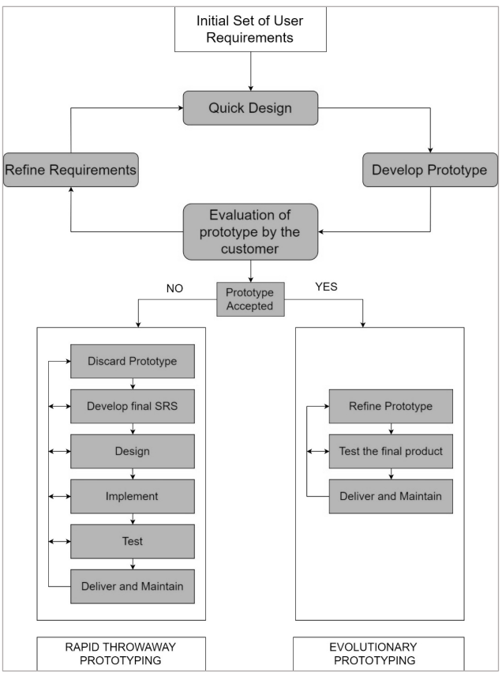

1. **Class Diagram**

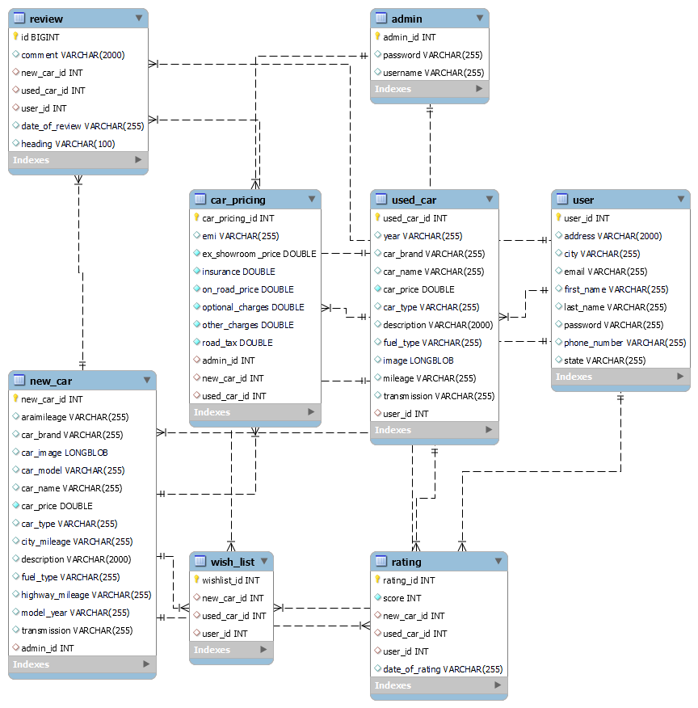

1. **ER Diagram**

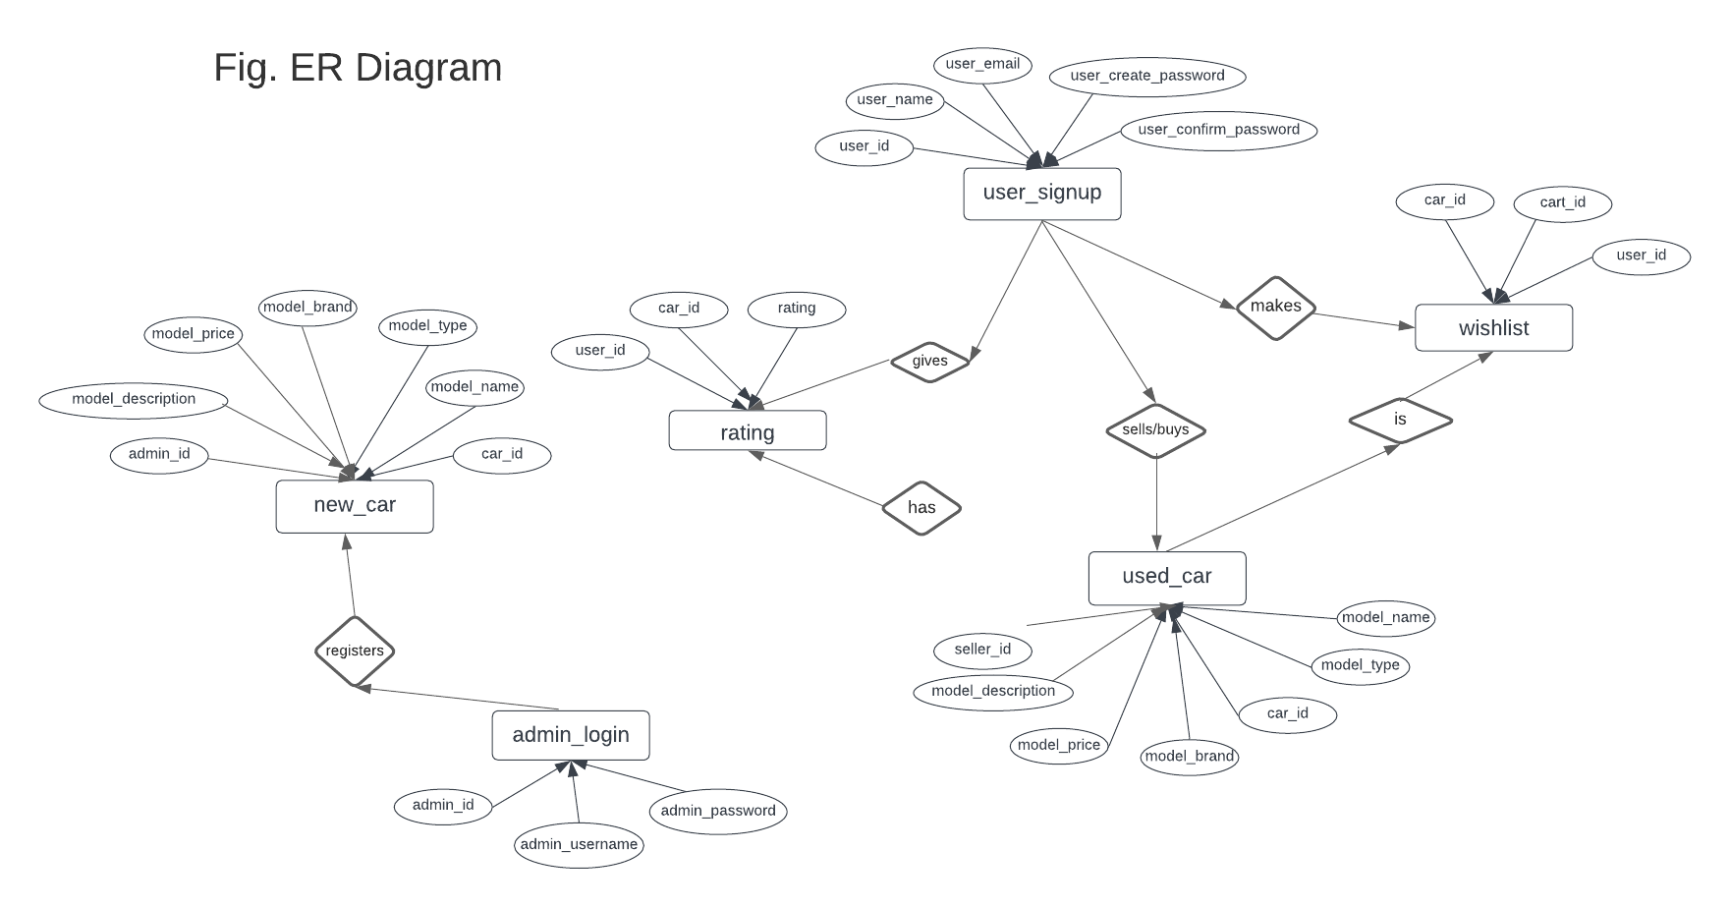

1. **Data-Flow Diagram**
   1. User Module

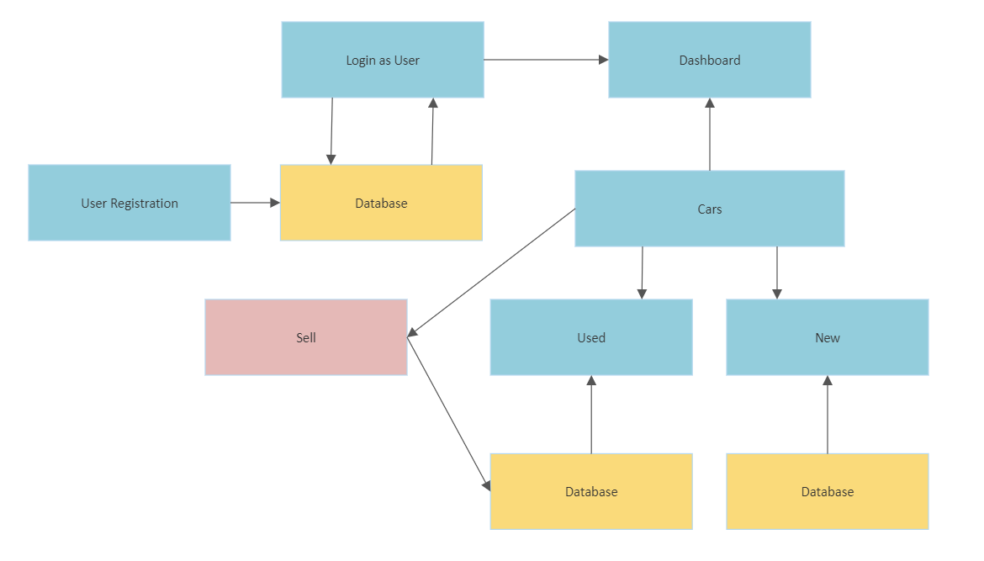

1. Admin Module

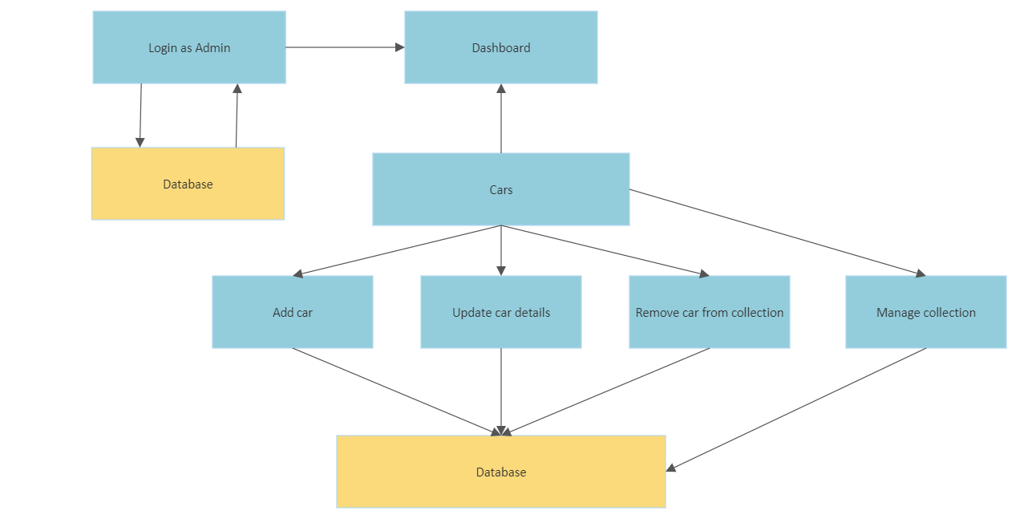

* **Use-Case Diagram**

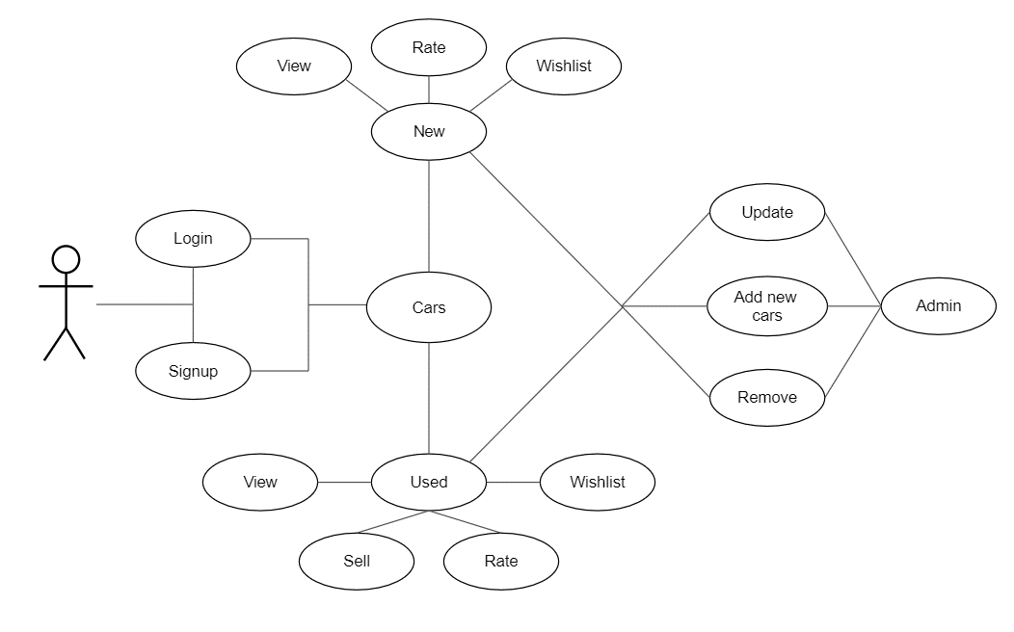

* **Sequence Diagram**

